Paper Title e.g: Please use Times New Roman, 14 Point and Bold

Author Name e.g: Normal Bold^{1*}, Ali Hamzah^{1,2}, Razak Rahman³, Font Twelve Point ³
(empty line)
Line 1 (of Affiliation): ¹Dept. Name of Organization, Name of Organization, acronyms acceptable
line 2-City, Country
Line 1 (of Affiliation): ² Dept. Name of Organization, Name of Organization, acronyms acceptable
line 2-City, Country
Line 1 (of Affiliation): ³ Dept. Name of Organization, Name of Organization, acronyms acceptable
line 2-City, Country
(empty line)
*Corresponding author’s phone: +603-8921 5473
E-mail: chiachinhua@yahoo.com / chia@ukm.my
(empty line)
(empty line)

ABSTRACT
A concise and factual abstract is required. The abstract should state briefly the purpose of the research, the principal results and major conclusions. An abstract is often presented separately from the article, so it must be able to stand alone. For this reason, References must be avoided. Also, non-standard or uncommon abbreviations should be avoided, but if essential they must be defined at their first mention in the abstract itself. The abstract should NOT be more than 200 words in length and must be in a single paragraph. Font type is Times New Roman, Font No 12. Immediately after the abstract, provide a maximum of 5 keywords, avoiding general and plural terms and multiple concepts (avoid, for example, "and", "of"). Be sparing with abbreviations: only abbreviations firmly established in the field may be eligible. These keywords will be used for indexing purposes. ‘ABSRACT’ word must be bold and in capital letter.
Keywords—component; formatting; style; styling; insert
(empty line)
- INTRODUCTION
The author should provide an adequate background of the study stating the importance and the novelty of the research. The author should avoid discussing detailed literature review or summary of the results in this section. The article must be divided into numbered sections. Each section and subsection should be numbered 1.1, then 1.1.1, 1.1.2, 1.2, etc. The abstract is not included in section numbering. The subsection must be given a brief heading. Heading for each section and subsection should appear on its own separate line.
(empty line)
- THEORY/LITERATURE REVIEW
A theory section should extend, not repeat, the background to the article already dealt with in the Introduction and justify the foundation for the practical work. Provide clear detail of calculations made such that they could be reproduced.
(empty line)
- MATERIALS
Provide sufficient detail of the materials used and their source to allow the work to be reproduced.
(empty line)
- EXPERIMENTAL
Provide sufficient detail including the apparatus/equipment used to allow the work to be reproduced. Methods already published should be indicated by a reference: only relevant modifications should be described.
(empty line)
  - Selecting a Template
First, confirm that you have the correct template for your paper size. This template has been tailored for output on the A4 paper size. If you are using US letter-sized paper, please close this file and download the file “MSW_USltr_format”.
(empty line)

Maintaining the Integrity of the Specifications
The template is used to format your paper and style the text. All margins, column widths, line spaces, and text fonts are prescribed; please do not alter them. Please use paragraph spacing at 0 point for ‘before’ and ‘after’ and single line spacing. You can click at “Paragraph” to format the spacing. You may note peculiarities. For example, the head margin in this template measures proportionately more than is customary. This measurement and others are deliberate, using specifications that anticipate your paper as one part of the entire proceedings, and not as an independent document. Please do not revise any of the current designations.
(empty line)
- RESULTS AND DISCUSSION
Results should be clear and concise. A combined Results and Discussion section is often appropriate. This section should discuss the significance of the results of the research. Avoid extensive citations and discussion of published literature.
(empty line)

5.1 Figures and Tables

Positioning Figures and Tables: Place figures and tables at the top and bottom of pages. Avoid placing them in the middle of pages. Figure captions should be below the figures; table heads should appear above the tables. Insert figures and tables after they are cited in the text. Use the abbreviation “Fig. 1,” even at the beginning of a sentence.
(empty line)
TABLE I: Title of Table, Center Text and Bold
11 point,
Times
New
Roman,
Bold
Table Head | Table Column Head
Table Head | Table column subhead | Subhead | Subhead
Copy | More table copyª
- Sample of a table footnote if any. (Font size 10)
We suggest that you use a text box to insert a graphic (which is ideally a 500 dpi resolution TIFF or EPS file with all fonts embedded) because this method is somewhat more stable than directly inserting a picture.
To have non-visible rules on your frame, use the MSWord “Format” pull-down menu, select Text Box > Colors and Lines to choose No Fill and No Line. Please use 12-point Times New Roman. Number the illustrations according to their sequence in the text. Use a logical naming convention for your artwork files

Fig. 1: Example of a figure caption. Font Size 10,
use “Fig.” rather than “Figure”, center text
(empty line)
Figure Labels: Use 12 point Times New Roman for Figure labels. Use words rather than symbols or abbreviations when writing Figure axis labels to avoid confusing the reader. As an example, write the quantity “Magnetization,” or “Magnetization, M,” not just “M.” If including units in the label, present them within parentheses. Do not label axes only with units. In the example, write “Magnetization (A/m)” or “Magnetization (A ( m(1),” not just “A/m.” Do not label axes with a ratio of quantities and units. For example, write “Temperature (K),” not “Temperature/K.”
(empty line)

Abbreviations and Acronyms
Define abbreviations that are not standard in this field in the text at their first mention. Such abbreviations that are unavoidable in the abstract must be defined at their first mention there. Ensure consistency of abbreviations throughout the article.
(empty line)

Units
    - Use either SI (MKS) or CGS as primary units. (SI units are encouraged.) English units may be used as secondary units (in parentheses). An exception would be the use of English units as identifiers in trade, such as “3.5-inch disk drive.”
    - Avoid combining SI and CGS units, such as current in amperes and magnetic field in oersteds. This often leads to confusion because equations do not balance dimensionally. If you must use mixed units, clearly state the units for each quantity that you use in an equation.
    - Do not mix complete spellings and abbreviations of units: “Wb/m2” or “webers per square meter,” not “webers/m2.” Spell units when they appear in text: “...a few henries,” not “...a few H.”
    - Use a zero before decimal points: “0.25,” not “.25.” Use “cm3,” not “cc.”
(empty line)

Equations
The equations are an exception to the prescribed specifications of this template. You will need to determine whether or not your equation should be typed using either the Times New Roman or the Symbol font (please no other font). To create multileveled equations, it may be necessary to treat the equation as a graphic and insert it into the text after your paper is styled.
(empty line)
Number equations consecutively. Equation numbers, within parentheses, are to position flush right, as in (1), using a right tab stop. To make your equations more compact, you may use the solidus ( / ), the exp function, or appropriate exponents. Italicize Roman symbols for quantities and variables, but not Greek symbols. Use a long dash rather than a hyphen for a minus sign. Punctuate equations with commas or periods when they are part of a sentence, as in
a  b    
Note that the equation is centered using a center tab stop. Be sure that the symbols in your equation have been defined before or immediately following the equation. Use “(1),” not “Eq. (1)” or “equation (1),” except at the beginning of a sentence: “Equation (1) is ...”
(empty line)
5.5 Footnotes
Footnotes should be used sparingly. Number them consecutively throughout the article, using superscript Arabic numbers. Many word processors build footnotes into the text, and this feature may be used. Should this not be the case, indicate the position of footnotes in the text and present the footnotes themselves separately at the end of the article. Do not include footnotes in the Reference list. Table footnotes indicate each footnote in a table with a superscript lowercase letter.
(empty line)
5.5 Margin and Column Setup
Please see Fig. 2 and Fig.3 for margin and column layout in your paper template.

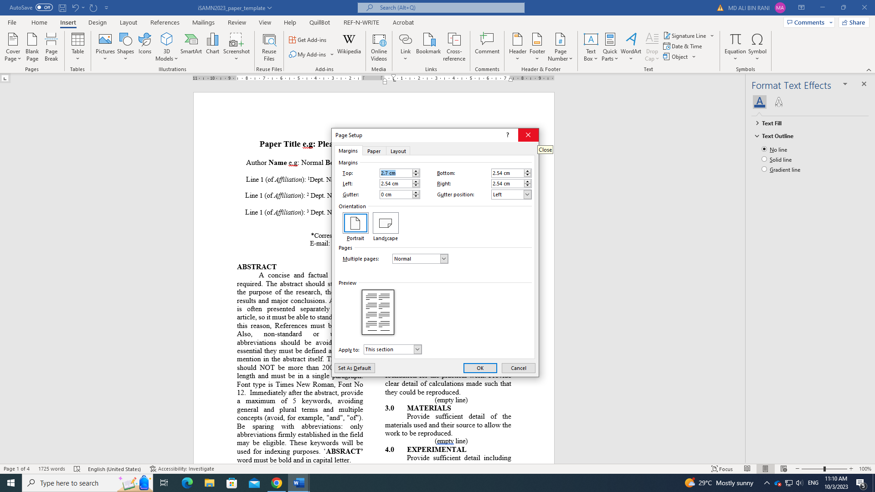

Fig. 2: Margin setup
(empty line)
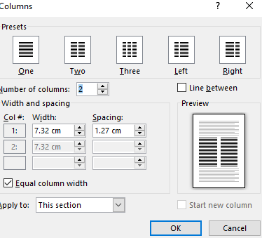
Fig. 3: Column setup
(empty line)
- CONCLUSION
The main findings or conclusions of the study may be presented in a short conclusion section.
(empty line)
ACKNOWLEDGEMENTS
An acknowledgement should be provided in a separate section at the end of the article before the references and do not, therefore, include them on a title page, as a footnote to the title or otherwise.
Please do not numbering ACKNOWLEDGEMENTS and REFERENCES
(empty line)
REFERENCES
Citation within text
Please ensure that every reference cited in the text is also present in the reference list (and vice versa). Any references cited in the abstract must be given in full. Unpublished results and personal communications are not

recommended in the reference list, but may be mentioned in the text.

If these references are included in the reference list they should follow the standard reference style of the journal and should include a substitution of the

publication date with either 'Unpublished results' or 'Personal communication'. Citation of a reference as 'in press' implies that the item has been accepted for publication.

Reference style
All publications cited in the text should be presented in a list of references following the text of the manuscript. In the text refer to references by a number in square brackets on the line (e.g. Since Askeland [1]), and the full reference should be given in a numerical list at the end of the paper.

References should be given in the following form:
1. D. R. Askeland, The science and engineering of materials. 2nd ed. Chapman and Hall. 1984.
2. N. Brown and X. Lu, In: Proceedings of the 12th Plastic Fuel Gas Pipe Symposium, Boston, 1991. pp. 128-133.
3. P. J. Rankin, A. T. Horvath, and D. J. Klingenberg, “Magnetorheology in viscoplastic media,” Rheol Acta, vol. 38, no. 5, pp. 471–477, 1999.

