Extended Abstract Title

First Author¹, Second Author^{1,2,*}, Third Author³

¹Complete affiliation 1
²Complete affiliation 2
³Complete affiliation 3
*Corresponding Author’s Email: xxx@xxx.xxx

Abstract: The extended abstract should be written with 11 font size, Times New Roman, justified, single line spacing. Objective, method and results are summarized in this section. (Maximum 100 words with spacing)

Keywords: This section should contain maximum 3-5 words that are written in 10 font size and separated with commas.

INTRODUCTION
The introduction section should (1) present the scope and objective of the paper and state the problem, (2) briefly review the pertinent literature, (3) describe the methods, and (4) provide an overview of the main results of the work.

Authors are requested to submit the extended abstract in electronic form (MS-Word) via our Online Submission. Please ensure the extended abstract has a minimum of two (2) pages and maximum of three (3) pages in the length including the references.

MATERIALS AND METHODS

The methodology must be clearly stated and described in sufficient detail or with sufficient references. The in-text citations in this extended abstract should be numbered and enclosed in square brackets ‘[]’ only. For example: [1].

RESULTS AND DISCUSSION
The results and discussion of the work should be explicitly described and illustrated. Supporting figures, tables and images of the results (no more than two figures and two tables) may be included in the extended abstract.

All the tables, images, and figures should be centered. Figures and images should be numbered (see Fig. 1 for an example) and figure headers should be placed under the figure or image; as for the tables, they should also be numbered (see Table 2 for an example) and the table header should be placed at the top.

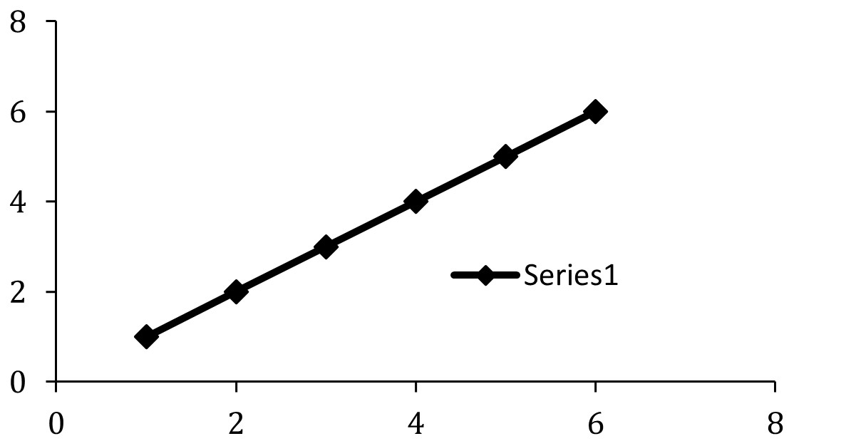

Fig. 1. Example of figure for the extended abstract.

Table 2. Example of table for the extended abstract.
Materials | Values

CONCLUSION
Conclusions should include (1) the principles and generalisations inferred from the results, (2) any exceptions to, or problems with these principles and generalisations, (3) practical implications of the work, and (4) conclusions drawn and recommendations.

Acknowledgment: (Optional) The authors would like to express appreciation for the support of the sponsors [Project Number = XXX].

REFERENCES
[1] Suzuki M, Shinkai M, Honda H, Kobayashi T. Melanoma Res., 2003, 13, 129.
[2] Hwang HY, Kim IS, Kwon IC, Kim YH. J. Control. Release, 2008, 128, 23.
[3] Book Chapter Mohammad F, du Plessis L, Arfin T, X-ray analysis of metal oxide-metal core-shell nanoparticles, In: Shih, K. (ed.), Nova Science Publishers, Inc. New York, 2013, pp. 161-181.
[4] Webpage.http://www.johnshopkinshealthalerts.com/alerts_index/cancer/2669-1.html/March 28 (2014)

